https://docs.aws.amazon.com/sdk-for-java/v1/developer-guide/examples-dynamodb.html
DynamoDB Examples Using the AWS SDK for Java - AWS SDK for Java 1.x
Programming Amazon DynamoDB using the AWS SDK for Java
https://docs.aws.amazon.com/amazondynamodb/latest/developerguide/DynamoDBLocal.DownloadingAndRunnin…
Deploying DynamoDB locally on your computer - Amazon DynamoDB
Learn how to download and deploy Amazon DynamoDB locally on your computer. Use DynamoDB local to develop and test code before deploying applications on the DynamoDB web service.

https://docs.aws.amazon.com/amazondynamodb/latest/developerguide/DynamoDBLocal.DownloadingAndRunning.html#DynamoDBLocal.DownloadingAndRunning.title

Create root account:
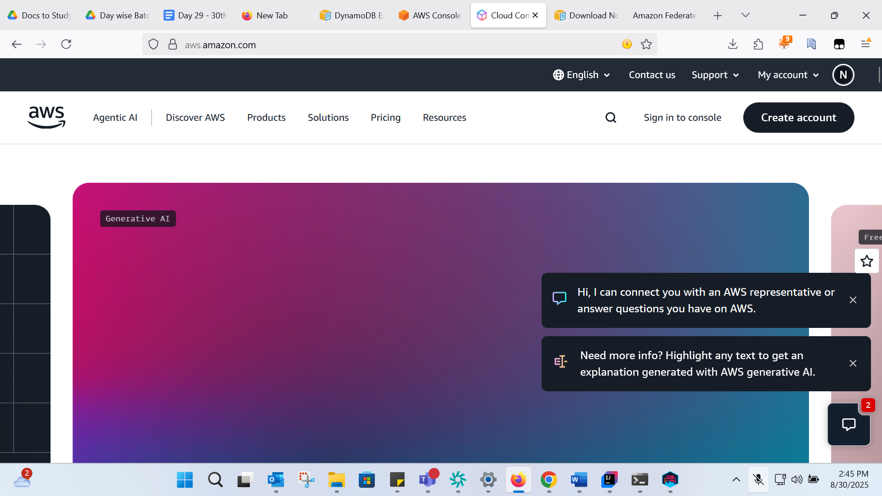

Dynamo DB:
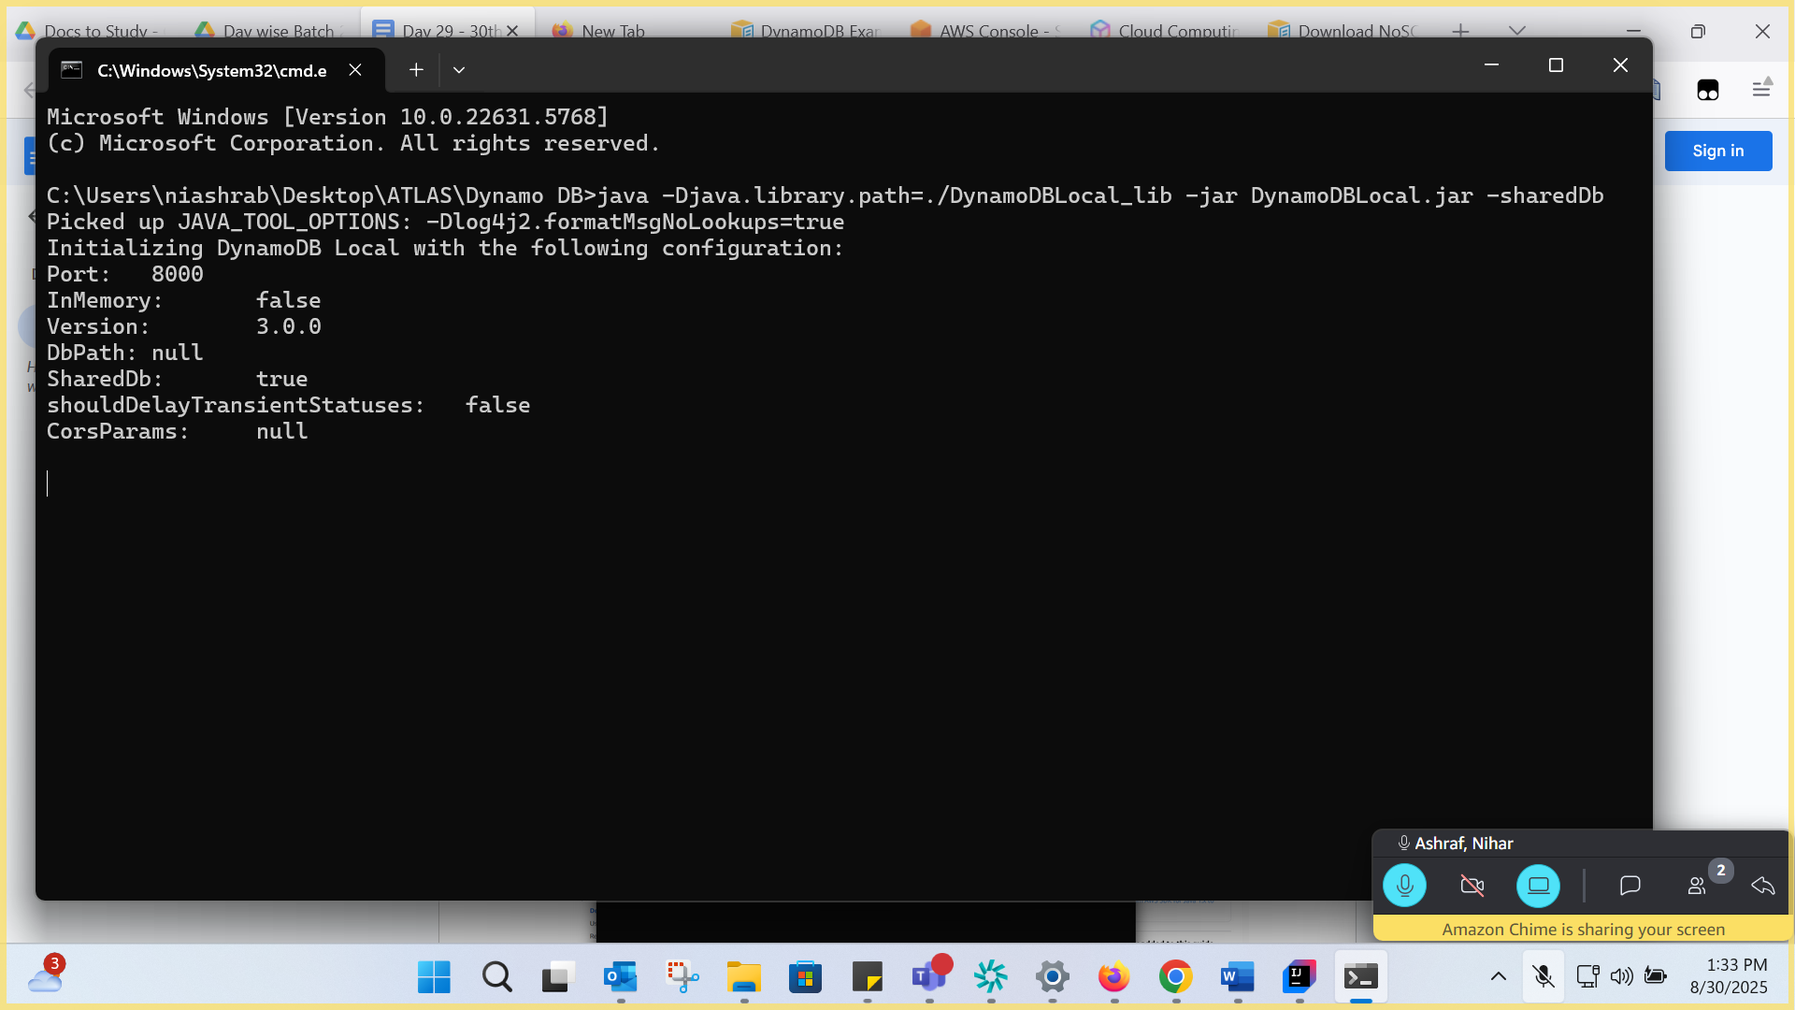
NO SQL:
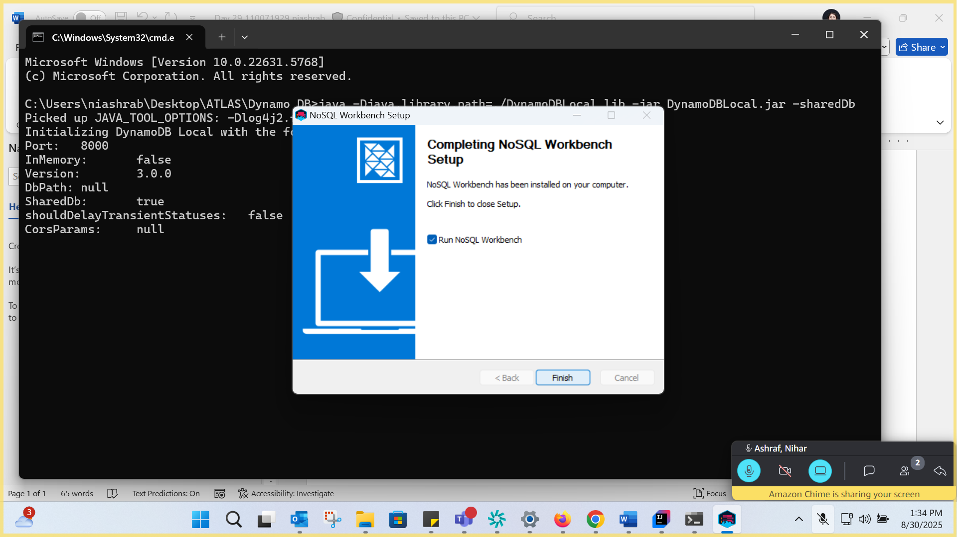
Task 2:
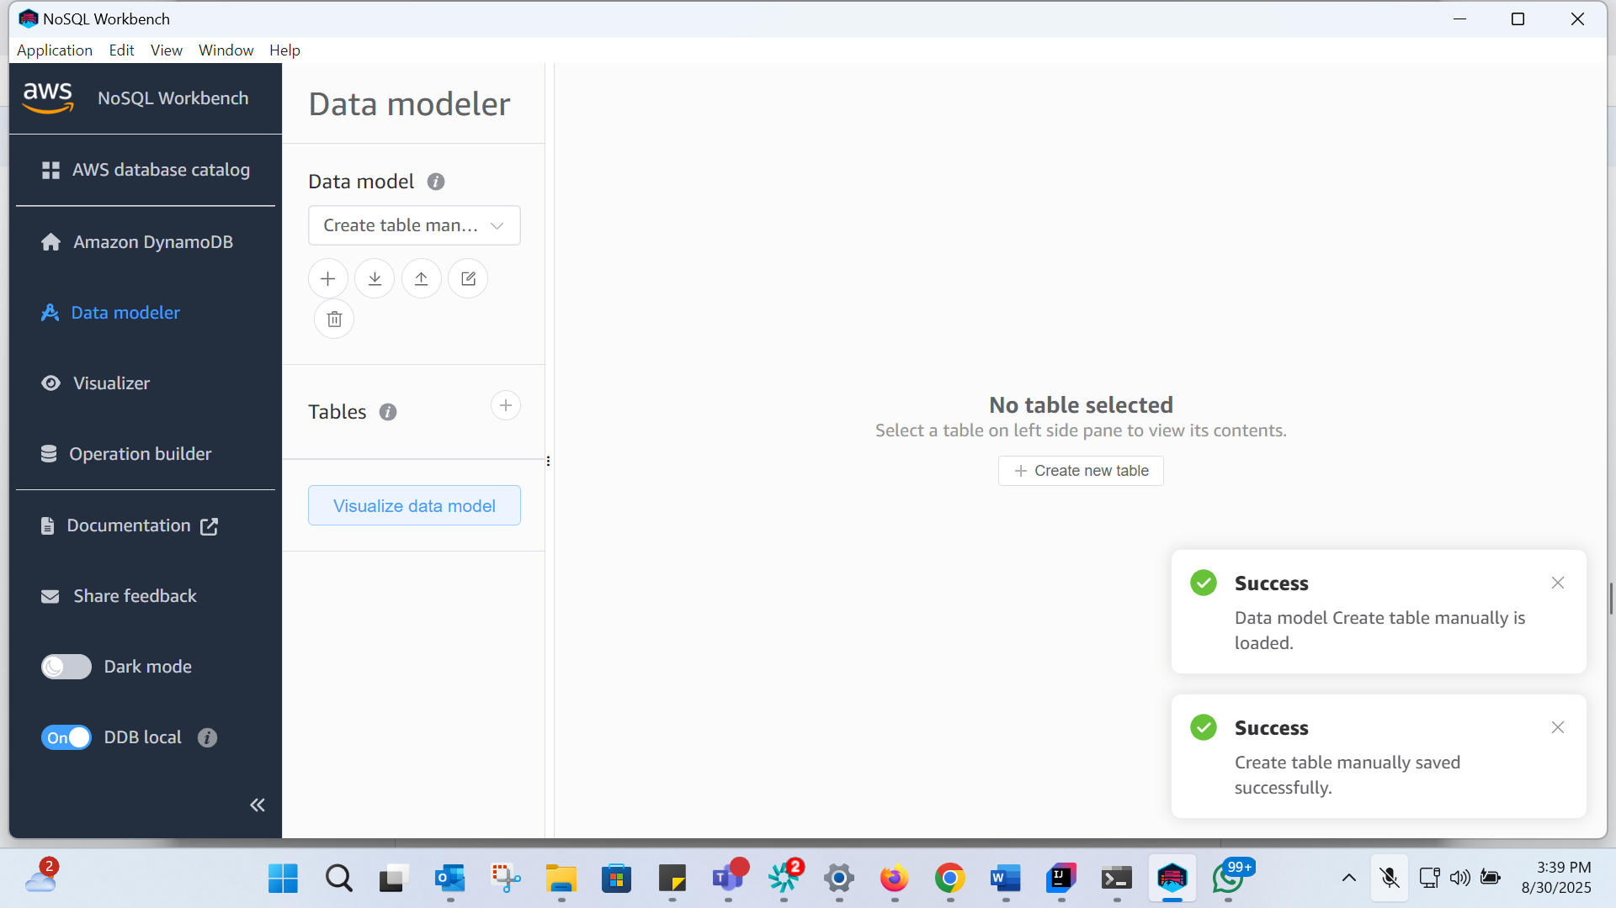
Task 2:
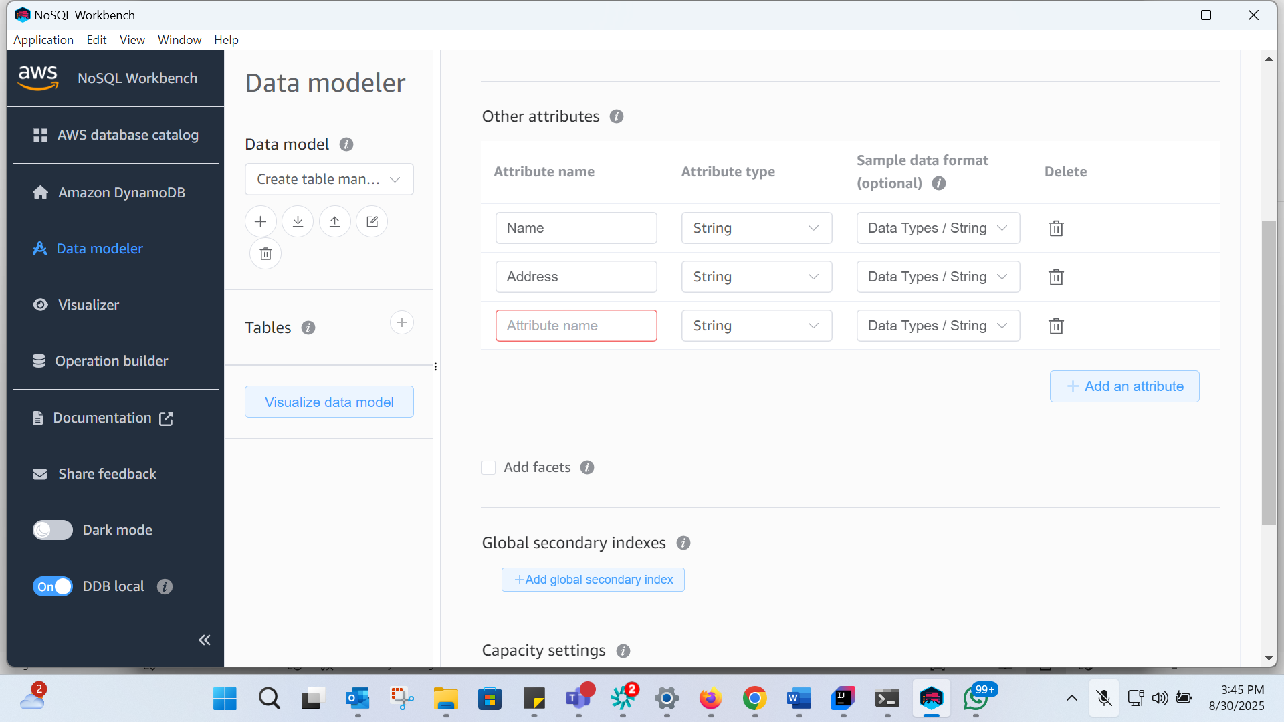
AWS Version:
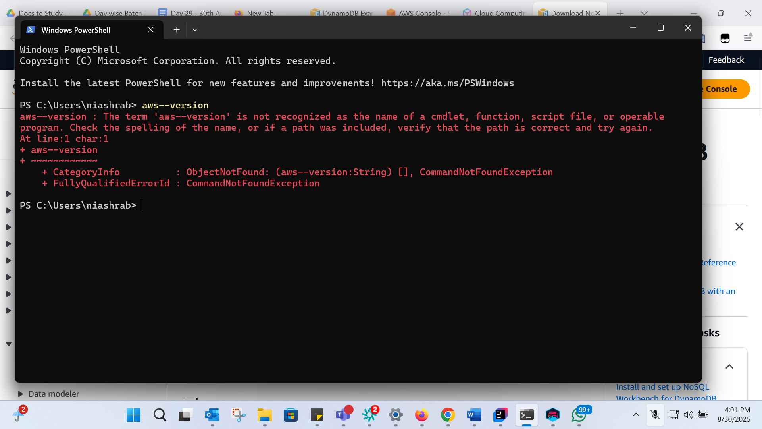
https://docs.aws.amazon.com/cli/latest/userguide/getting-started-install.html
AWS Version:
